TouchForge: Forging Games & Gadgets from a Single Touch
A Step-by-Step Build Cookbook — Touch Sensor, ESP32 & OLED
How This Cookbook Works
We are not going to jump straight to "build a motion-controlled game." That's how you end up with a pile of components that don't talk to each other and no idea which one is broken.
Instead, we build one capability at a time, test it, and only then bolt on the next one.
One small capacitive touch module is the hero of the whole build. Every experiment uses it as the input, and each one asks a bigger question of it:
Experiment | You will be able to... | New hardware added
1 | Read a touch as a clean HIGH / LOW signal and react with light | Touch module + onboard LED
2 | Turn a single tap into a game: jump, dodge, score | OLED display
3 | Decode short and long touches into letters — Morse code | Buzzer
4 | Measure human reaction time to the millisecond | (logic only — state machine + calibration)
5 | Aim with tilt, shoot with touch, and drive any browser game | MPU6050 motion sensor + Python on your PC
By Experiment 5 you will have a complete custom game controller: tilt the board to move the mouse, tap the sensor to click — and the game itself never needs to be modified.
Every experiment ends with a Checkpoint
A specific thing you should see happen. Do not move to the next experiment until your checkpoint passes.

Setup
Components Needed
Component | Qty | Notes
ESP32 Dev Board | 1 | Any standard 30-pin ESP32-WROOM devkit
Capacitive touch module | 1 | 3-pin: SIG, VCC, GND. Digital output — HIGH when touched
OLED Display (SSD1306, 128x64, I2C) | 1 | 4-pin: VCC, GND, SDA, SCL. Used from Experiment 2
Buzzer module | 1 | 3-pin: S, VCC, GND. Used in Experiments 3 and 4
MPU6050 motion sensor | 1 | Used in Experiment 5 only
Small breadboard, jumper wires | — | Everything fits on one small breadboard
USB cable | 1 | Data-capable, not charge-only
Software & Libraries
1. Install Arduino IDE (2.x) and add ESP32 board support (Tools → Board → Boards Manager → search "esp32" → install the Espressif Systems package).
2. Select Tools → Board → ESP32 Arduino → ESP32 Dev Module and the correct Tools → Port.
3. Install these libraries via Sketch → Include Library → Manage Libraries: Adafruit GFX Library, Adafruit SSD1306 (from Experiment 2) and MPU6050\_light (Experiment 5).
4. For Experiment 5 you also need Python 3 on your PC with pyserial and pyautogui (pip install pyserial pyautogui).
The Full Pin Map
Wire each part when its experiment arrives — the pins never conflict, so nothing you wired earlier ever has to move.
Function | ESP32 Pin | Used from
Onboard LED | GPIO 2 (built-in — no wiring) | Experiment 1
Touch SIG | GPIO 4 | Experiment 1
Touch VCC / GND | 3V3 / GND | Experiment 1
OLED SDA | GPIO 21 | Experiment 2
OLED SCL | GPIO 22 | Experiment 2
OLED VCC | 3V3 | Experiment 2
Buzzer S (signal) | GPIO 18 | Experiment 3
MPU6050 SDA / SCL | GPIO 21 / GPIO 22 (shared I²C bus) | Experiment 5
MPU6050 VCC | 3V3 | Experiment 5
How the Touch Module Works
- The module watches a metal pad for the tiny change in capacitance caused by your finger, and turns it into a plain digital signal on SIG: LOW when idle, HIGH while touched.
- That means we read it with digitalRead() — no special touch API needed. We set the pin to INPUT\_PULLDOWN so it reads a clean LOW when nothing is touching.
- Two ideas are reused in every experiment: the level (is it HIGH right now?) and the edge (did it just change from LOW to HIGH?). Edges are how a touch becomes a single "tap" event.
Warning
Power the touch module, OLED, buzzer and MPU6050 from 3V3, never 5V. Also keep your fingers and loose wires away from the pad while the board boots — the module calibrates itself on power-up.

Experiment 1: Touch → LED
Goal
Light the ESP32's onboard LED while you touch the sensor, and print every touch to the Serial Monitor. It's the "hello world" of this whole workshop — it proves your board, cable, upload toolchain and touch module all work.
A Little Theory
- A GPIO pin can drive a voltage (OUTPUT) or read one (INPUT). Here GPIO 4 reads the touch module and GPIO 2 drives the onboard LED.
- INPUT\_PULLDOWN adds a weak internal resistor to GND, so the pin sits at a clean LOW instead of "floating" when the module is idle.
- digitalWrite(LED\_PIN, t) works because HIGH and LOW are just 1 and 0 — the LED simply mirrors the sensor.
- We only print when the state changes (t != lastTouch). Printing every loop would flood the Serial Monitor thousands of times a second.
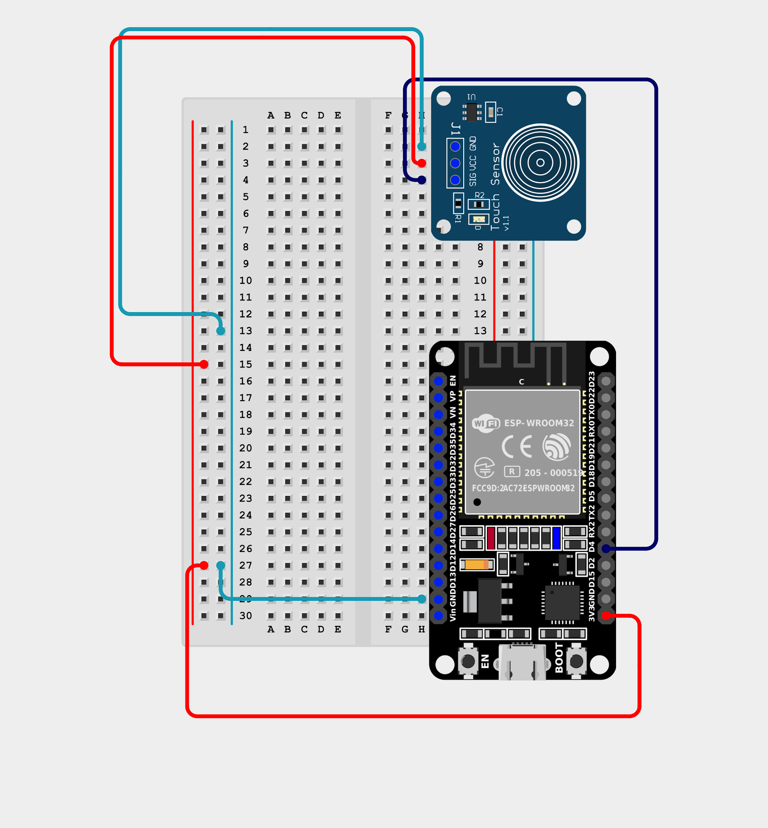
Touch wiring — SIG → GPIO 4, VCC → 3V3, GND → GND. The LED is the built-in one on GPIO 2 (no wiring).
Full Code
/*
TouchForge — Experiment 1: Touch → LED
Touch the sensor and the ESP32's onboard LED lights up.
Hardware: Touch SIG->GPIO4, VCC->3V3, GND->GND, LED on GPIO2 (built-in)
*/

const int TOUCH_PIN = 4;
const int LED_PIN = 2;

int lastTouch = LOW;

void setup() {
Serial.begin(115200);
pinMode(TOUCH_PIN, INPUT_PULLDOWN); // idle = LOW, touched = HIGH
pinMode(LED_PIN, OUTPUT);
Serial.println("=== TouchForge | Experiment 1: Touch -> LED ===");
}

void loop() {
int t = digitalRead(TOUCH_PIN); // read the sensor
digitalWrite(LED_PIN, t); // LED mirrors the sensor

if (t != lastTouch) { // only print when it changes
Serial.println(t == HIGH ? "TOUCHED" : "released");
lastTouch = t;
}
}
Code Walkthrough
- pinMode(TOUCH\_PIN, INPUT\_PULLDOWN): configures GPIO 4 as an input with a built-in pull-down.
- digitalRead(TOUCH\_PIN): returns HIGH (1) while touched, LOW (0) when not.
- lastTouch: remembers the previous reading so we can spot the moment it changes.
- Open Tools → Serial Monitor at 115200 baud to see TOUCHED / released appear.
Checkpoint
Touch the pad → the small onboard LED turns on and the Serial Monitor prints TOUCHED. Let go → LED off and released prints.
Common Errors
- ​LED never lights: check the module is on 3V3 and SIG goes to GPIO 4. Some boards have the onboard LED on a different GPIO — check the silkscreen.
- ​Upload fails: hold the BOOT button while the IDE says "Connecting…".
- ​LED flickers on its own: keep fingers and wires off the pad at power-up; reset the board and try again.
- ​Nothing in Serial Monitor: baud rate must be 115200.

Challenge: Tap Once to Turn ON, Tap Again to Turn OFF
Your Task
Right now the LED only stays on while you hold the pad. Make it behave like a real light switch instead:
- ​First tap: LED turns on and stays on after you let go.
- ​Second tap: LED turns off.
- Print LED ON / LED OFF to the Serial Monitor each time.
The point: learn edge detection. Reacting to the moment of touch, not the level, is the pattern every later experiment depends on.
Hints
- Keep a bool ledOn that remembers the LED's current state.
- A tap is t == HIGH && lastTouch == LOW — flip ledOn only then.
- Update lastTouch = t at the end of every loop.
Checkpoint
Tap → LED turns on and stays on. Tap again → LED off. One tap always changes the LED exactly once, even if you hold your finger down.
You now have a working touch input.
From here on we keep the same sensor on GPIO 4 and give it a screen to talk to.

This cookbook will be continued in Part 2.
Experiment 2: Touch Dino
Goal
Build a Chrome-style Dino runner on the 128×64 OLED. Touch = jump. Dodge the cacti, rack up a score, and watch the onboard LED light up whenever the dino is in the air.
New Libraries Required
- Adafruit GFX Library
- Adafruit SSD1306
A Little Theory
- The OLED talks over I²C: SDA → GPIO 21, SCL → GPIO 22. Its address is almost always 0x3C (sometimes 0x3D).
- The Adafruit library keeps a pixel buffer in RAM. You draw into it, and nothing shows until display.display() pushes the buffer to the panel.
- A game is a loop: read input → update the world → draw the frame. We run it at a fixed ~33 frames per second (FRAME\_MS = 30).
- Jumping is simple physics: a tap gives the dino an upward velocity (JUMP\_V), and gravity (GRAVITY) pulls it back every frame.
- We check the touch pin on every pass of loop() and remember a tap in tapPending — so a quick tap between two frames is never lost.
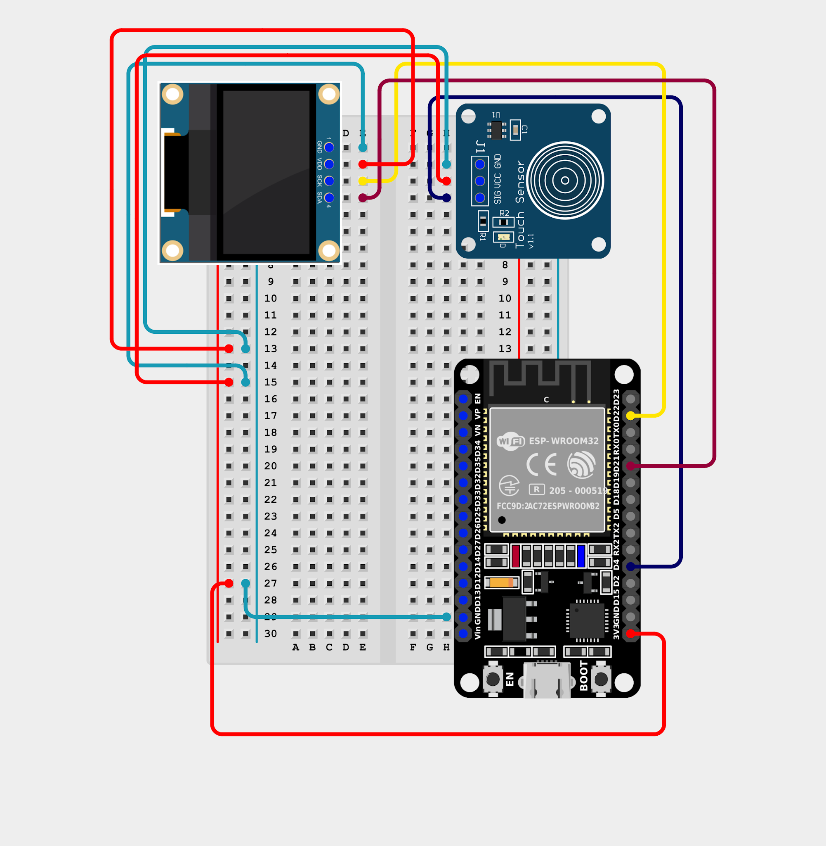
Touch + OLED — Touch SIG → GPIO 4, OLED SDA/SCL → GPIO 21/22, both modules on 3V3 and GND. Onboard LED on GPIO 2.
Full Code
/*
TouchForge — Experiment 2: Touch Dino
Touch sensor = JUMP. Dodge the cacti. Onboard LED lights while airborne.
Hardware: Touch SIG->GPIO4, OLED SDA->GPIO21, SCL->GPIO22, LED on GPIO2
*/

#include <Wire.h>
#include <Adafruit_GFX.h>
#include <Adafruit_SSD1306.h>

// ---------- Display ----------
#define SCREEN_W 128
#define SCREEN_H 64
#define OLED_ADDR 0x3C // change to 0x3D if your screen stays blank
Adafruit_SSD1306 display(SCREEN_W, SCREEN_H, &Wire, -1);

// ---------- Pins ----------
const int TOUCH_PIN = 4;
const int LED_PIN = 2;

// ---------- Game constants ----------
const int GROUND_Y = 54; // y of ground line
const int DINO_X = 14; // dino's fixed x position
const int DINO_H = 12;
const float GRAVITY = 0.8; // pixels/frame^2
const float JUMP_V = -7.5; // initial jump velocity (negative = up)
const unsigned long FRAME_MS = 30; // ~33 frames per second
const int MAX_OBS = 2;

// ---------- Game state ----------
enum GameState { START, PLAYING, GAMEOVER };
GameState state = START;

struct Obstacle { float x; int w; int h; bool passed; };
Obstacle obs[MAX_OBS];

float dinoY, dinoV;
bool onGround;
float speed;
int score = 0, best = 0;
unsigned long frameCount = 0, lastFrame = 0, gameOverAt = 0;

// ---------- Touch input ----------
int lastTouch = LOW;
bool tapPending = false; // remembers a tap until the next frame uses it

// ================= Drawing helpers =================
void drawDino(int x, int y) {
display.fillRect(x + 4, y, 7, 5, WHITE); // head
display.drawPixel(x + 8, y + 1, BLACK); // eye
display.fillRect(x, y + 4, 8, 6, WHITE); // body
display.fillRect(x - 2, y + 5, 2, 2, WHITE); // tail
if (onGround && (frameCount / 4) % 2) { // running legs animation
display.fillRect(x + 1, y + 10, 2, 2, WHITE);
} else if (onGround) {
display.fillRect(x + 5, y + 10, 2, 2, WHITE);
} else { // legs tucked while jumping
display.fillRect(x + 1, y + 10, 2, 2, WHITE);
display.fillRect(x + 5, y + 10, 2, 2, WHITE);
}
}

void drawCactus(const Obstacle &o) {
int top = GROUND_Y - o.h;
display.fillRect((int)o.x, top, o.w, o.h, WHITE);
if (o.h > 10) { // arms on taller cacti
display.fillRect((int)o.x - 2, top + 3, 2, 4, WHITE);
display.fillRect((int)o.x + o.w, top + 5, 2, 3, WHITE);
}
}

void drawGround() {
display.drawLine(0, GROUND_Y, SCREEN_W - 1, GROUND_Y, WHITE);
int offset = (int)(frameCount * speed) % 16; // scrolling pebbles
for (int x = -offset; x < SCREEN_W; x += 16) {
display.drawPixel(x + 3, GROUND_Y + 3, WHITE);
display.drawPixel(x + 10, GROUND_Y + 6, WHITE);
}
}

void drawScore() {
char buf[12];
sprintf(buf, "SCORE:%03d", score);
display.setTextSize(1);
display.setCursor(SCREEN_W - 54, 0);
display.print(buf);
}

// ================= Game logic =================
void spawnObstacle(int i) {
float farthest = 0;
for (int j = 0; j < MAX_OBS; j++) if (j != i && obs[j].x > farthest) farthest = obs[j].x;
obs[i].x = max((float)SCREEN_W, farthest + random(70, 130)); // keep a jumpable gap
obs[i].w = random(4, 8);
obs[i].h = random(8, 15);
obs[i].passed = false;
}

void resetGame() {
dinoY = GROUND_Y - DINO_H;
dinoV = 0;
onGround = true;
speed = 3.0;
score = 0;
frameCount = 0;
obs[0].x = 0; obs[1].x = 0;
obs[0].x = SCREEN_W + 20; obs[0].w = 5; obs[0].h = 10; obs[0].passed = false;
spawnObstacle(1);
}

bool hitTest(const Obstacle &o) {
// dino hitbox (slightly smaller than the drawing = fairer game)
int dx = DINO_X + 1, dy = (int)dinoY + 2, dw = 8, dh = DINO_H - 2;
int ox = (int)o.x, oy = GROUND_Y - o.h, ow = o.w, oh = o.h;
return dx < ox + ow && dx + dw > ox && dy < oy + oh && dy + dh > oy;
}

void updatePlaying(bool tap) {
// 1. Input -> jump (only if standing on ground)
if (tap && onGround) {
dinoV = JUMP_V;
onGround = false;
}

// 2. Physics
if (!onGround) {
dinoV += GRAVITY;
dinoY += dinoV;
if (dinoY >= GROUND_Y - DINO_H) { // landed
dinoY = GROUND_Y - DINO_H;
dinoV = 0;
onGround = true;
}
}

// 3. Obstacles move, score, respawn, collide
for (int i = 0; i < MAX_OBS; i++) {
obs[i].x -= speed;

if (!obs[i].passed && obs[i].x + obs[i].w < DINO_X) {
obs[i].passed = true;
score++;
speed = min(3.0 + score * 0.15, 7.0); // difficulty ramps up
}
if (obs[i].x + obs[i].w < 0) spawnObstacle(i);

if (hitTest(obs[i])) {
state = GAMEOVER;
gameOverAt = millis();
if (score > best) best = score;
}
}

digitalWrite(LED_PIN, onGround ? LOW : HIGH); // LED = "in the air"
}

// ================= Screens =================
void drawStartScreen() {
display.setTextSize(2);
display.setCursor(4, 8);
display.print("TOUCH DINO");
display.setTextSize(1);
display.setCursor(22, 36);
display.print("Touch to start");
display.setCursor(34, 50);
display.print("BEST: ");
display.print(best);
}

void drawGameOverScreen() {
display.setTextSize(2);
display.setCursor(10, 4);
display.print("GAME OVER");
display.setTextSize(1);
display.setCursor(30, 28);
display.print("SCORE: "); display.print(score);
display.setCursor(30, 40);
display.print("BEST: "); display.print(best);
if (millis() - gameOverAt > 1000) { // short lockout before restart
display.setCursor(22, 54);
display.print("Touch to retry");
}
}

// ================= Setup & Loop =================
void setup() {
Serial.begin(115200);
pinMode(TOUCH_PIN, INPUT_PULLDOWN);
pinMode(LED_PIN, OUTPUT);

Wire.begin(21, 22); // SDA, SCL
if (!display.begin(SSD1306_SWITCHCAPVCC, OLED_ADDR)) {
Serial.println("OLED not found! Check wiring / address.");
while (true) { // fast blink = OLED error
digitalWrite(LED_PIN, !digitalRead(LED_PIN));
delay(100);
}
}
display.setTextColor(WHITE);
randomSeed(esp_random());
resetGame();
Serial.println("=== TouchForge | Experiment 2: Touch Dino ===");
}

void loop() {
// Check touch EVERY loop so no tap is missed between frames
int t = digitalRead(TOUCH_PIN);
if (t == HIGH && lastTouch == LOW) tapPending = true; // rising edge
lastTouch = t;

// Run the game at a fixed frame rate
if (millis() - lastFrame < FRAME_MS) return;
lastFrame = millis();
frameCount++;

bool tap = tapPending;
tapPending = false;

display.clearDisplay();

switch (state) {
case START:
drawStartScreen();
if (tap) { resetGame(); state = PLAYING; }
break;

case PLAYING:
updatePlaying(tap);
drawGround();
for (int i = 0; i < MAX_OBS; i++) drawCactus(obs[i]);
drawDino(DINO_X, (int)dinoY);
drawScore();
break;

case GAMEOVER:
digitalWrite(LED_PIN, (millis() / 250) % 2); // blink LED
drawGameOverScreen();
if (tap && millis() - gameOverAt > 1000) {
resetGame();
state = PLAYING;
}
break;
}

display.display(); // push the frame to the OLED
}
Code Walkthrough
- enum GameState { START, PLAYING, GAMEOVER }: a tiny state machine decides which screen to draw and what a tap means.
- tapPending: set on the LOW→HIGH edge of the touch pin, consumed by the next frame. Same idea as the Experiment 1 challenge.
- updatePlaying(): applies the jump (only if onGround), runs the physics, moves the cacti, scores a point when one passes the dino, and checks collisions.
- hitTest(): a rectangle-overlap test. The dino's hitbox is deliberately a little smaller than its drawing, which makes the game feel fairer.
- speed = min(3.0 + score \* 0.15, 7.0): difficulty ramps up with every cactus you clear, capped so it stays playable.
- spawnObstacle(): places the next cactus a random but always jumpable distance after the farthest one.
- The onboard LED is HIGH while airborne and blinks on Game Over — instant feedback even if you're not looking at the screen.
- On Game Over there is a 1-second lockout before a tap restarts the game, so your last frantic tap doesn't skip the score screen.
Checkpoint
The OLED shows TOUCH DINO. Tap → the game starts and the dino runs. Tap → it jumps (LED on in the air). Hit a cactus → GAME OVER with your score and best.
Common Errors
- ​Screen stays black: try address 0x3D, and double-check SDA/SCL aren't swapped.
- ​LED blinks fast and nothing else happens: that is the "OLED not found" signal — check power (3V3) and wiring.
- ​Dino jumps by itself: the touch module is noisy — keep the pad away from loose wires and reset the board.
- ​Taps feel ignored: you can only jump while on the ground — wait for the landing.
Experiment 3: Touch Morse
Goal
Turn the touch sensor into a Morse code key. Short touch = dot, long touch = dash. The board beeps as you key, decodes letters and digits, and shows the message live on the OLED.
A Little Theory
- Morse is just timing. A press shorter than DASH\_MS (250 ms) is a dot; longer is a dash. Presses shorter than NOISE\_MS (30 ms) are ignored as noise.
- A pause of LETTER\_GAP\_MS (0.7 s) ends the letter; WORD\_GAP\_MS (1.8 s) adds a space; holding for CLEAR\_MS (2 s) clears everything.
- Decoding is a table lookup: the dots and dashes you typed (like .-) are compared against MORSE\_TABLE for A–Z and 0–9.
- The buzzer uses the ESP32's LEDC hardware PWM: ledcAttach() sets it up, ledcWriteTone(pin, freq) starts a square wave and ledcWriteTone(pin, 0) stops it. This is cleaner and louder than tone() on a piezo.
- Wiring: buzzer S → GPIO 18, VCC → 3V3, GND → GND.
Gesture | Meaning | Feedback
Touch < 250 ms | DOT | Short beep at 5000 Hz
Touch ≥ 250 ms | DASH | Pitch drops to 3500 Hz and the onboard LED lights
Pause 0.7 s | End of letter | Letter is decoded and added to the message
Pause 1.8 s | End of word | A space is added
Hold 2 s | Clear all | OLED header shows CLEAR?
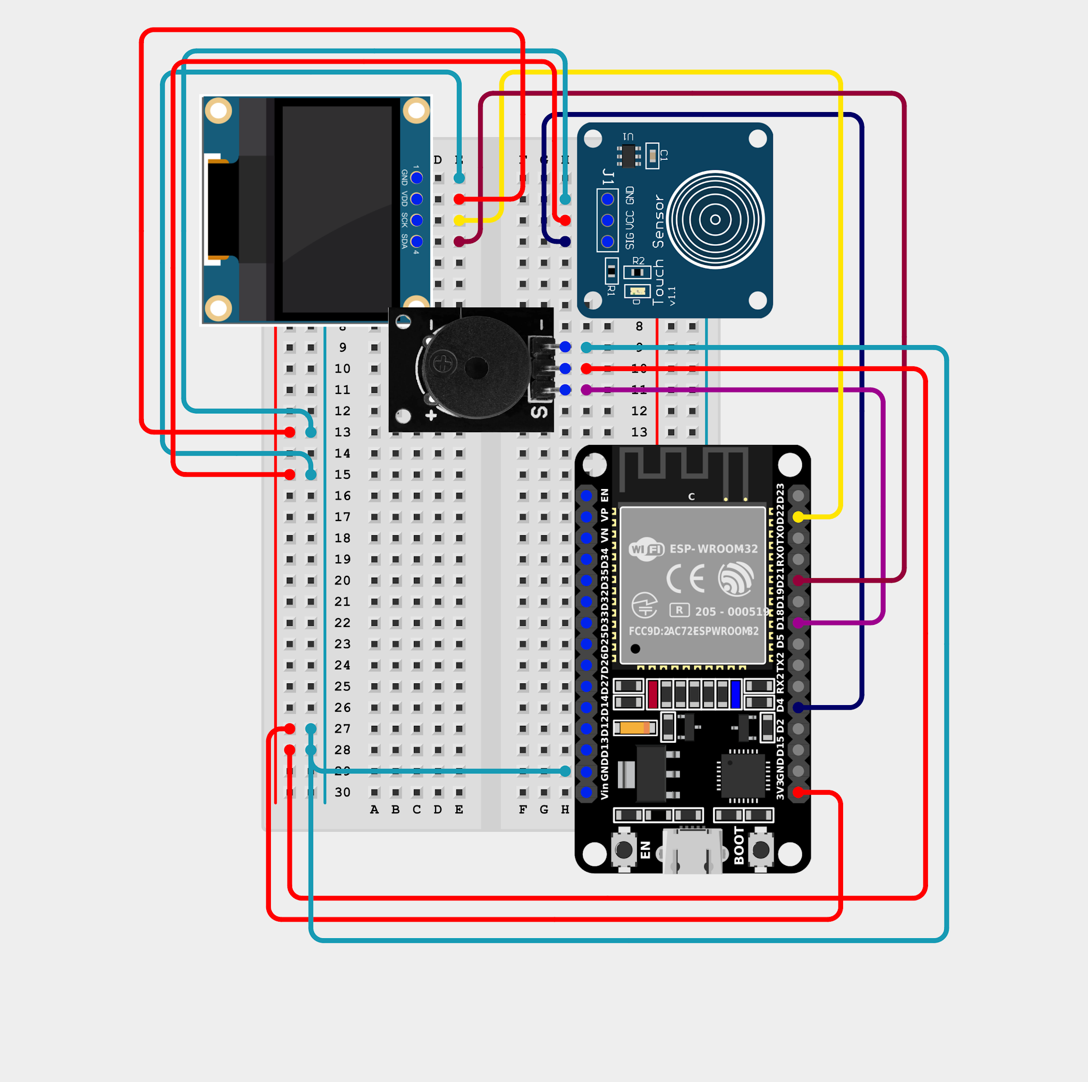
Touch + OLED + buzzer — Buzzer S → GPIO 18 is the only new wire. Onboard LED on GPIO 2.
Full Code
/*
TouchForge — Experiment 3: Touch Morse (letters + digits, live preview, LEDC buzzer)
------------------------------------------------------------------
Short touch = DOT (buzzer short beep)
Long touch = DASH (buzzer long beep, onboard LED lights at DASH point)
Pause 0.7 s = end of letter
Pause 1.8 s = end of word (space)
Hold 2 s = clear everything

The letter being typed is shown LIVE in an inverted box on the OLED.

Wiring (30-pin ESP32):
Touch SIG -> GPIO 4 | VCC -> 3V3 | GND -> GND
OLED SDA -> GPIO 21 | SCL/SCK -> GPIO 22 | VCC -> 3V3 | GND -> GND
Buzzer S -> GPIO 18 | VCC -> 3V3 | GND -> GND
Onboard LED -> GPIO 2

BUZZER: driven with the ESP32's LEDC hardware PWM (ledcAttach/ledcWriteTone)
instead of digitalWrite/tone(). This gives a cleaner square wave and is
usually noticeably louder on a piezo disc, especially near its resonance.
*/

#include <Wire.h>
#include <Adafruit_GFX.h>
#include <Adafruit_SSD1306.h>

// ================= Display =================
#define SCREEN_W 128
#define SCREEN_H 64
#define OLED_ADDR 0x3C // change to 0x3D if the screen stays blank
Adafruit_SSD1306 display(SCREEN_W, SCREEN_H, &Wire, -1);

// ================= Pins =================
const int TOUCH_PIN = 4;
const int LED_PIN = 2;
const int BUZZER_PIN = 18;

// ================= Buzzer configuration (LEDC) =================
const int PWM_RES_BITS = 8; // 8-bit resolution (0-255 duty)
int DOT_FREQ = 5000; // Hz, tune to your buzzer's loudest point
int DASH_FREQ = 3500; // Hz, slightly lower pitch for DASH

// ================= Morse timing (ms) =================
const unsigned long NOISE_MS = 30; // shorter = ignored
const unsigned long DASH_MS = 250; // < 250 DOT, >= 250 DASH
const unsigned long CLEAR_MS = 2000; // hold = clear all
const unsigned long LETTER_GAP_MS = 700; // pause -> commit letter
const unsigned long WORD_GAP_MS = 1800; // longer pause -> space
const unsigned long BAR_MAX_MS = 750; // progress bar full scale
const unsigned int MAX_SYMBOLS = 5; // longest valid code is 5

// ================= Morse table: letters A-Z and digits 0-9 =================
struct MorseCode {
char ch;
const char* code;
};

const MorseCode MORSE_TABLE[] = {
// ---- Letters A-Z ----
{'A', ".-"}, {'B', "-..."}, {'C', "-.-."}, {'D', "-.."},
{'E', "."}, {'F', "..-."}, {'G', "--."}, {'H', "...."},
{'I', ".."}, {'J', ".---"}, {'K', "-.-"}, {'L', ".-.."},
{'M', "--"}, {'N', "-."}, {'O', "---"}, {'P', ".--."},
{'Q', "--.-"}, {'R', ".-."}, {'S', "..."}, {'T', "-"},
{'U', "..-"}, {'V', "...-"}, {'W', ".--"}, {'X', "-..-"},
{'Y', "-.--"}, {'Z', "--.."},

// ---- Digits 0-9 ----
{'0', "-----"}, {'1', ".----"}, {'2', "..---"}, {'3', "...--"},
{'4', "....-"}, {'5', "....."}, {'6', "-...."}, {'7', "--..."},
{'8', "---.."}, {'9', "----."}
};
const int MORSE_COUNT = sizeof(MORSE_TABLE) / sizeof(MORSE_TABLE[0]);
const char UNKNOWN_CHAR = '*'; // pattern that matches nothing

// ================= State =================
bool touching = false; // key held right now?
bool dashZone = false; // this press crossed DASH threshold?
bool wordGapDone = true;
unsigned long pressStart = 0, lastRelease = 0, lastDraw = 0;
String symbol = ""; // dots/dashes of current letter
String message = ""; // decoded text
String history = ""; // Morse of recent letters
char lastChar = ' ';
bool redraw = true;

// ================= Buzzer (LEDC) =================
void buzzerOn(int freq) {
ledcWriteTone(BUZZER_PIN, freq); // starts a square wave at `freq`
}

void buzzerOff() {
ledcWriteTone(BUZZER_PIN, 0); // 0 Hz = silent
}

void beep(int ms) { // blocking, startup only
buzzerOn(DOT_FREQ); delay(ms); buzzerOff();
}

// ================= Morse helpers =================
char decodeMorse(const String &s) {
for (int i = 0; i < MORSE_COUNT; i++) {
if (s == MORSE_TABLE[i].code) return MORSE_TABLE[i].ch;
}
return UNKNOWN_CHAR;
}

void keepLast(String &s, unsigned int n) {
if (s.length() > n) s = s.substring(s.length() - n);
}

void commitLetter() {
char c = decodeMorse(symbol);
Serial.print(symbol); Serial.print(" -> "); Serial.println(c);

message += c;
history += symbol + " ";
lastChar = c;
symbol = "";
keepLast(message, 20); // 2 lines x 10 big characters
keepLast(history, 21); // 1 line x 21 small characters
redraw = true;
}

// Dots/dashes typed so far + the one being held right now
String liveSymbol(unsigned long now) {
String s = symbol;
if (touching) {
unsigned long held = now - pressStart;
if (held >= NOISE_MS && held < CLEAR_MS) {
s += (held < DASH_MS) ? '.' : '-'; // what this press WOULD be
}
}
return s;
}

// ================= Display =================
void drawScreen(unsigned long now) {
display.clearDisplay();
display.setTextSize(1);
display.setTextColor(WHITE);

String live = liveSymbol(now);
char preview = (live.length() > 0) ? decodeMorse(live) : 0; // 0 = nothing typed

// ---- Header ----
display.setCursor(0, 0);
display.print("MORSE");
display.setCursor(80, 0);
if (touching && now - pressStart >= CLEAR_MS) {
display.print("CLEAR?");
} else if (preview) {
display.print("NOW:");
display.print(preview);
} else {
display.print("LAST:");
display.print(lastChar);
}
display.drawLine(0, 9, 127, 9, WHITE);

// ---- Morse history + live symbol ----
String line = history + live;
keepLast(line, 21);
display.setCursor(0, 13);
display.print(line);

// ---- Hold-time bar with DOT|DASH marker ----
if (touching) {
unsigned long held = min(now - pressStart, BAR_MAX_MS);
int w = map(held, 0, BAR_MAX_MS, 0, 127);
int dashX = map(DASH_MS, 0, BAR_MAX_MS, 0, 127);
display.drawRect(0, 24, 128, 5, WHITE);
display.fillRect(0, 24, w, 5, WHITE);
display.drawLine(dashX, 22, dashX, 30, WHITE);
}

// ---- Message + live preview letter (inverted box) ----
String shown = message;
if (preview) shown += preview;
keepLast(shown, 20);

display.setTextSize(2);
for (unsigned int i = 0; i < shown.length(); i++) {
int x = (i % 10) * 12;
int y = 32 + (i / 10) * 16;
bool isPreview = preview && (i == shown.length() - 1);

if (isPreview) {
display.fillRect(x, y, 12, 16, WHITE);
display.setTextColor(BLACK);
} else {
display.setTextColor(WHITE);
}
display.setCursor(x, y);
display.print(shown[i]);
}
display.setTextColor(WHITE);

display.display();
}

// ================= Setup =================
void setup() {
Serial.begin(115200);

pinMode(TOUCH_PIN, INPUT_PULLDOWN);
pinMode(LED_PIN, OUTPUT);
digitalWrite(LED_PIN, LOW);

// Attach LEDC hardware PWM to the buzzer pin (starting freq/resolution
// are placeholders; buzzerOn()/buzzerOff() change the freq each call)
ledcAttach(BUZZER_PIN, DOT_FREQ, PWM_RES_BITS);
buzzerOff();

Wire.begin(21, 22);
if (!display.begin(SSD1306_SWITCHCAPVCC, OLED_ADDR)) {
Serial.println("OLED not found! Check wiring / address.");
while (true) { digitalWrite(LED_PIN, !digitalRead(LED_PIN)); delay(100); }
}
display.setTextColor(WHITE);

Serial.println("=== TouchForge | Experiment 3: Touch Morse ===");
Serial.println("Short = DOT, long = DASH, pause = next letter, hold 2 s = CLEAR");
Serial.print("Morse table loaded: ");
Serial.print(MORSE_COUNT);
Serial.println(" characters");

beep(80); delay(80); beep(80); // startup chirp
delay(500); // touch module calibration
drawScreen(millis());
}

// ================= Loop (state machine) =================
void loop() {
unsigned long now = millis();
int t = digitalRead(TOUCH_PIN);

// --- PRESS STARTED ---
if (t == HIGH && !touching) {
touching = true;
dashZone = false;
pressStart = now;
buzzerOn(DOT_FREQ);
redraw = true;
}

// --- HOLDING ---
if (t == HIGH && touching) {
unsigned long held = now - pressStart;
if (!dashZone && held >= DASH_MS) {
dashZone = true;
digitalWrite(LED_PIN, HIGH); // LED = "this will be a DASH"
buzzerOn(DASH_FREQ); // pitch drops for DASH
}
if (now - lastDraw > 40) redraw = true; // animate bar + preview
}

// --- RELEASED ---
if (t == LOW && touching) {
touching = false;
buzzerOff();
digitalWrite(LED_PIN, LOW);
unsigned long held = now - pressStart;

if (held >= CLEAR_MS) {
symbol = ""; message = ""; history = ""; lastChar = ' ';
Serial.println("[CLEARED]");
} else if (held >= NOISE_MS) {
char s = (held < DASH_MS) ? '.' : '-';
symbol += s;
Serial.print(s == '.' ? "DOT " : "DASH ");
Serial.print(held); Serial.println(" ms");
if (symbol.length() >= MAX_SYMBOLS) commitLetter(); // too long -> '*'
}
lastRelease = now;
wordGapDone = false;
redraw = true;
}

// --- WAITING: letter and word gaps ---
if (!touching) {
unsigned long gap = now - lastRelease;

if (symbol.length() > 0 && now - lastDraw > 100) redraw = true;

if (symbol.length() > 0 && gap >= LETTER_GAP_MS) {
commitLetter();
}
if (!wordGapDone && symbol.length() == 0 && gap >= WORD_GAP_MS) {
wordGapDone = true;
if (message.length() > 0 && !message.endsWith(" ")) {
message += ' ';
history += "/ ";
keepLast(message, 20);
keepLast(history, 21);
Serial.println("[SPACE]");
redraw = true;
}
}
}

if (redraw) {
drawScreen(now);
redraw = false;
lastDraw = now;
}
}
Code Walkthrough
- struct MorseCode { char ch; const char\* code; } + MORSE\_TABLE[]: the whole alphabet and digits in one array; decodeMorse() loops through it to find a match.
- The loop() is a timing state machine: press started → holding → released → waiting. Each branch only looks at millis(), never delay(), so the buzzer and display stay responsive.
- liveSymbol(): predicts what the current press would become, so the OLED can show a live preview of the letter in an inverted box while you are still holding.
- The hold-time bar has a marker at the DOT|DASH boundary — watch it fill and release just before or after the marker to learn the rhythm.
- keepLast(): trims the message to what fits on screen (2 lines × 10 big characters).
- A 5-symbol limit commits the letter automatically; an unknown pattern is shown as \*.
Checkpoint
Tap short–long (.-) and wait → the OLED shows A. Key ... --- ... (with letter pauses) → it spells SOS. Hold for 2 seconds → the screen clears.
Common Errors
- ​No sound: buzzer S must go to GPIO 18; check it is a module that takes a tone signal.
- ​Dots turn into dashes: press more crisply — under 250 ms. Watch the bar marker on the OLED.
- ​Letters split too early / too late: tune LETTER\_GAP\_MS and WORD\_GAP\_MS at the top of the sketch.
- ​ledcAttach not found: you need ESP32 Arduino core 3.x. On older 2.x cores use ledcSetup() + ledcAttachPin().
What changed from Experiment 2
- The touch is now measured by duration (how long), not just as an edge (when).
- New output: the LEDC buzzer on GPIO 18.
- The OLED is redrawn only when something changes, instead of every frame.

This cookbook will be continued in Part 3.
Experiment 4: F1 Reaction Finder
Goal
Recreate the Formula 1 start: a countdown of 3-2-1, a random wait, then the lights go out — and you tap as fast as you can. The board measures your reaction time to the millisecond and keeps your best.
A Little Theory
- The program is a state machine built from plain #define integers (ST\_IDLE, ST\_COUNT3 … ST\_TIMEOUT). Each state has one job and one way out.
- To be fair, the "go" moment is random: after the countdown the game waits HOLD\_MIN\_MS–HOLD\_MAX\_MS (1.2–4 s) so you can't guess it.
- Reaction time is measured with micros() from the instant the screen goes blank until the touch edge arrives — far finer than millis().
- Tapping before the lights go out is a false start: a low buzz and a penalty screen. Not tapping within 3 s is a timeout.
- At boot the sketch calibrates the touch module: for 3 seconds it listens while you do not touch it, measures the longest spurious blip and sets a noise threshold from it.
State | What you see | What happens next
ST\_IDLE | F1 REACTION + best time | Tap to start
ST\_COUNT3 / 2 / 1 | Big 3, 2, 1 with a beep each | Any tap now = false start
ST\_COUNTSTART | START + LED on | Moves to the random hold
ST\_HOLD | READY | After a random 1.2–4 s the screen goes blank
ST\_GO | Blank screen (lights out!) | Tap now — the clock is running
ST\_RESULT | Your time, current and best | Tap for the next run
ST\_FALSESTART / ST\_TIMEOUT | FALSE START! / TOO SLOW | Tap to retry
Same wiring as Experiment 3 — touch, OLED and buzzer. Nothing new to connect.
Full Code
/*
TouchForge — Experiment 4: F1 Reaction Finder (v2 + calibration)
No enum used — plain int state machine, to rule out enum ordering issues.
*/

#include <Wire.h>
#include <Adafruit_GFX.h>
#include <Adafruit_SSD1306.h>

#define SCREEN_W 128
#define SCREEN_H 64
#define OLED_ADDR 0x3C
Adafruit_SSD1306 display(SCREEN_W, SCREEN_H, &Wire, -1);

const int TOUCH_PIN = 4;
const int LED_PIN = 2;
const int BUZZER_PIN = 18;

const int PWM_RES_BITS = 8;
const int COUNT_FREQ = 3000;
const int START_FREQ = 5000;
const int FALSE_FREQ = 1200;
const int BEST_FREQ = 4000;

void buzzerOn(int freq) { ledcWriteTone(BUZZER_PIN, freq); }
void buzzerOff() { ledcWriteTone(BUZZER_PIN, 0); }
void beep(int freq, int ms) { buzzerOn(freq); delay(ms); buzzerOff(); }

const unsigned long COUNT_STEP_MS = 700;
const unsigned long HOLD_MIN_MS = 1200;
const unsigned long HOLD_MAX_MS = 4000;
const unsigned long GO_TIMEOUT_MS = 3000;
const unsigned long RESULT_HOLD_MS = 800;
const unsigned long FALSESTART_HOLD_MS = 1500;
const unsigned long TIMEOUT_HOLD_MS = 800;

const unsigned long CAL_DURATION_MS = 3000;
unsigned long touchThresholdMs = 15;

// ---- State machine using plain int constants instead of enum ----
#define ST_IDLE 0
#define ST_COUNT3 1
#define ST_COUNT2 2
#define ST_COUNT1 3
#define ST_COUNTSTART 4
#define ST_HOLD 5
#define ST_GO 6
#define ST_RESULT 7
#define ST_FALSESTART 8
#define ST_TIMEOUT 9

int state = ST_IDLE;

unsigned long stateEnteredAt = 0;
unsigned long holdDelay = 0;
unsigned long goStartMicros = 0;

float currentTime = -1;
float bestTime = -1;
int attempts = 0;

int lastTouch = LOW;
bool tapPending = false;

void enterState(int s) {
state = s;
stateEnteredAt = millis();
}

void startCountdown() {
enterState(ST_COUNT3);
beep(COUNT_FREQ, 100);
}

void calibrateTouchSensor() {
display.clearDisplay();
display.setTextSize(1);
display.setCursor(10, 10);
display.print("CALIBRATING...");
display.setCursor(10, 28);
display.print("Do NOT touch sensor");
display.setCursor(30, 44);
display.print("Hold still");
display.display();

Serial.println("Calibrating touch sensor -- do not touch...");

unsigned long start = millis();
unsigned long longestBlip = 0;
unsigned long blipStart = 0;
bool inBlip = false;
int blipCount = 0;

while (millis() - start < CAL_DURATION_MS) {
int reading = digitalRead(TOUCH_PIN);
if (reading == HIGH && !inBlip) {
inBlip = true;
blipStart = millis();
blipCount++;
}
if (reading == LOW && inBlip) {
inBlip = false;
unsigned long blipLen = millis() - blipStart;
if (blipLen > longestBlip) longestBlip = blipLen;
}
}

touchThresholdMs = constrain(longestBlip + 10, 10, 80);

Serial.print("Calibration done. Spurious blips: ");
Serial.print(blipCount);
Serial.print(", longest: ");
Serial.print(longestBlip);
Serial.print(" ms -> threshold set to ");
Serial.print(touchThresholdMs);
Serial.println(" ms");

if (blipCount > 0) {
Serial.println("WARNING: sensor is noisy. Consider turning the onboard");
Serial.println("sensitivity trimmer, moving the pad away from wires,");
Serial.println("or shielding it from nearby metal.");
}

display.clearDisplay();
display.setTextSize(1);
display.setCursor(10, 15);
display.print("Calibration done");
display.setCursor(10, 32);
display.print("Threshold: ");
display.print(touchThresholdMs);
display.print("ms");
if (blipCount > 0) {
display.setCursor(10, 46);
display.print("Noise detected!");
}
display.display();
delay(1200);
}

void drawIdle() {
display.setTextSize(2);
display.setCursor(6, 6);
display.print("F1 REACTION");
display.setTextSize(1);
display.setCursor(14, 32);
display.print("Touch to start");
display.setCursor(10, 50);
display.print("BEST: ");
if (bestTime > 0) { display.print(bestTime, 3); display.print(" s"); }
else display.print("--");
}

void drawBigCenter(const char* text, int textSize) {
display.setTextSize(textSize);
int16_t x1, y1; uint16_t w, h;
display.getTextBounds(text, 0, 0, &x1, &y1, &w, &h);
display.setCursor((SCREEN_W - w) / 2, (SCREEN_H - h) / 2);
display.print(text);
}

void drawResult() {
display.setTextSize(2);
display.setCursor(10, 2);
display.print("REACTION");
display.setTextSize(2);
display.setCursor(10, 24);
display.print(currentTime, 3);
display.print("s");

display.setTextSize(1);
display.setCursor(4, 48);
display.print("CUR: "); display.print(currentTime, 3);
display.setCursor(70, 48);
display.print("BEST: "); display.print(bestTime, 3);

if (millis() - stateEnteredAt > RESULT_HOLD_MS) {
display.setCursor(20, 58);
display.print("Touch for next run");
}
}

void drawFalseStart() {
display.setTextSize(2);
display.setCursor(4, 10);
display.print("FALSE");
display.setCursor(4, 30);
display.print("START!");
display.setTextSize(1);
display.setCursor(2, 52);
display.print("Wait for lights out!");
}

void drawTimeout() {
display.setTextSize(2);
display.setCursor(10, 14);
display.print("TOO SLOW");
display.setTextSize(1);
display.setCursor(20, 40);
display.print("No touch detected");
display.setCursor(30, 52);
display.print("Touch to retry");
}

void setup() {
Serial.begin(115200);

pinMode(TOUCH_PIN, INPUT_PULLDOWN);
pinMode(LED_PIN, OUTPUT);
digitalWrite(LED_PIN, LOW);

ledcAttach(BUZZER_PIN, START_FREQ, PWM_RES_BITS);
buzzerOff();

Wire.begin(21, 22);
if (!display.begin(SSD1306_SWITCHCAPVCC, OLED_ADDR)) {
Serial.println("OLED not found! Check wiring / address.");
while (true) { digitalWrite(LED_PIN, !digitalRead(LED_PIN)); delay(100); }
}
display.setTextColor(WHITE);

calibrateTouchSensor();

randomSeed(esp_random());
Serial.println("=== TouchForge | Experiment 4: F1 Reaction Finder (v2) ===");

enterState(ST_IDLE);
}

void loop() {
int t = digitalRead(TOUCH_PIN);
if (t == HIGH && lastTouch == LOW) tapPending = true;
lastTouch = t;

unsigned long now = millis();

if (state == ST_IDLE) {
display.clearDisplay(); drawIdle(); display.display();
if (tapPending) { attempts = 0; startCountdown(); }
}
else if (state == ST_COUNT3) {
if (tapPending) { buzzerOn(FALSE_FREQ); enterState(ST_FALSESTART); }
else {
display.clearDisplay(); drawBigCenter("3", 4); display.display();
if (now - stateEnteredAt >= COUNT_STEP_MS) { enterState(ST_COUNT2); beep(COUNT_FREQ, 100); }
}
}
else if (state == ST_COUNT2) {
if (tapPending) { buzzerOn(FALSE_FREQ); enterState(ST_FALSESTART); }
else {
display.clearDisplay(); drawBigCenter("2", 4); display.display();
if (now - stateEnteredAt >= COUNT_STEP_MS) { enterState(ST_COUNT1); beep(COUNT_FREQ, 100); }
}
}
else if (state == ST_COUNT1) {
if (tapPending) { buzzerOn(FALSE_FREQ); enterState(ST_FALSESTART); }
else {
display.clearDisplay(); drawBigCenter("1", 4); display.display();
if (now - stateEnteredAt >= COUNT_STEP_MS) { enterState(ST_COUNTSTART); beep(START_FREQ, 120); }
}
}
else if (state == ST_COUNTSTART) {
if (tapPending) { buzzerOn(FALSE_FREQ); enterState(ST_FALSESTART); }
else {
display.clearDisplay(); drawBigCenter("START", 2); display.display();
digitalWrite(LED_PIN, HIGH);
if (now - stateEnteredAt >= COUNT_STEP_MS) {
holdDelay = random(HOLD_MIN_MS, HOLD_MAX_MS + 1);
enterState(ST_HOLD);
}
}
}
else if (state == ST_HOLD) {
if (tapPending) {
digitalWrite(LED_PIN, LOW);
buzzerOn(FALSE_FREQ);
enterState(ST_FALSESTART);
} else {
display.clearDisplay(); drawBigCenter("READY", 2); display.display();
if (now - stateEnteredAt >= holdDelay) {
digitalWrite(LED_PIN, LOW);
display.clearDisplay();
display.display();
goStartMicros = micros();
enterState(ST_GO);
}
}
}
else if (state == ST_GO) {
if (tapPending) {
unsigned long reactMicros = micros() - goStartMicros;
currentTime = reactMicros / 1000000.0;
attempts++;

bool newBest = (bestTime < 0 || currentTime < bestTime);
if (newBest) bestTime = currentTime;

Serial.print("Reaction #"); Serial.print(attempts);
Serial.print(": "); Serial.print(currentTime, 3);
Serial.println(newBest ? " s <-- NEW BEST" : " s");

enterState(ST_RESULT);
if (newBest) beep(BEST_FREQ, 100);
}
else if (now - stateEnteredAt > GO_TIMEOUT_MS) {
enterState(ST_TIMEOUT);
}
}
else if (state == ST_RESULT) {
display.clearDisplay(); drawResult(); display.display();
if (tapPending && now - stateEnteredAt > RESULT_HOLD_MS) startCountdown();
}
else if (state == ST_FALSESTART) {
display.clearDisplay(); drawFalseStart(); display.display();
if (now - stateEnteredAt > 300) buzzerOff();
if (tapPending && now - stateEnteredAt > FALSESTART_HOLD_MS) startCountdown();
}
else if (state == ST_TIMEOUT) {
display.clearDisplay(); drawTimeout(); display.display();
if (tapPending && now - stateEnteredAt > TIMEOUT_HOLD_MS) startCountdown();
}

tapPending = false;
if (state != ST_GO) delay(15);
}
Code Walkthrough
- enterState(s): switches state and stamps stateEnteredAt, so every state can measure "how long have I been here?".
- calibrateTouchSensor(): counts blips while idle, then sets touchThresholdMs (clamped 10–80 ms) and warns you if the sensor is noisy.
- drawBigCenter(): uses getTextBounds() to centre text exactly, whatever its size.
- goStartMicros = micros() is captured the instant the screen blanks; the result is (micros() - goStartMicros) / 1000000.0 seconds.
- In ST\_GO the loop skips its delay(15) so the touch is sampled as fast as possible — no lag added to your time.
- A new best triggers a high-pitched beep (BEST\_FREQ) and a NEW BEST line in the Serial Monitor.
Checkpoint
Do not touch while it says CALIBRATING.... Then tap, watch 3-2-1, wait for the screen to go blank, and tap → your time appears (a typical human is 0.20–0.35 s). Tap early → FALSE START!.
Common Errors
- ​False starts at the very first countdown: you touched the pad during calibration, or the sensor is noisy — reset and keep still for the first 3 seconds.
- ​Calibration says "Noise detected!": move the pad away from wires and metal, or adjust the module's sensitivity trimmer if it has one.
- ​Times look too fast (≈0.05 s): spurious touch signals — see above.
- ​Always "TOO SLOW": the touch isn't reaching GPIO 4 — re-check SIG wiring.
Experiment 5: Tilt-to-Aim + Touch-to-Shoot
Goal
Turn the board into a game controller. Tilting it moves your PC's mouse across the whole screen; touching the sensor clicks. A short Python script on your PC turns the ESP32's serial messages into real mouse movement — so it works with any mouse-aimed browser game, with no changes to the game itself.
New Libraries Required
- Arduino: MPU6050\_light
- Python: pyserial and pyautogui
A Little Theory
- The MPU6050 is an accelerometer + gyroscope on the same I²C bus as the OLED (GPIO 21 / 22). The MPU6050\_light library fuses them into easy tilt angles: getAngleX() = roll (left/right), getAngleY() = pitch (forward/back).
- mpu.calcOffsets() measures the sensor's resting error at boot — keep the board still and flat while it says Calibrating....
- The ESP32 does not move the mouse itself. It prints a tiny text protocol over USB serial, and the Python script on your PC reads it and moves the cursor.
- Touch is edge-detected like every other experiment: LOW→HIGH sends SHOOT\_ON (mouse down), HIGH→LOW sends SHOOT\_OFF (mouse up) — so holding the pad holds the click.
Serial message | Sent when | Python does
TILT,<roll>,<pitch> | Every ~30 ms (≈33 times/sec) | Maps the angles to a screen position and moves the mouse
SHOOT\_ON | Touch begins | mouseDown()
SHOOT\_OFF | Touch ends | mouseUp()
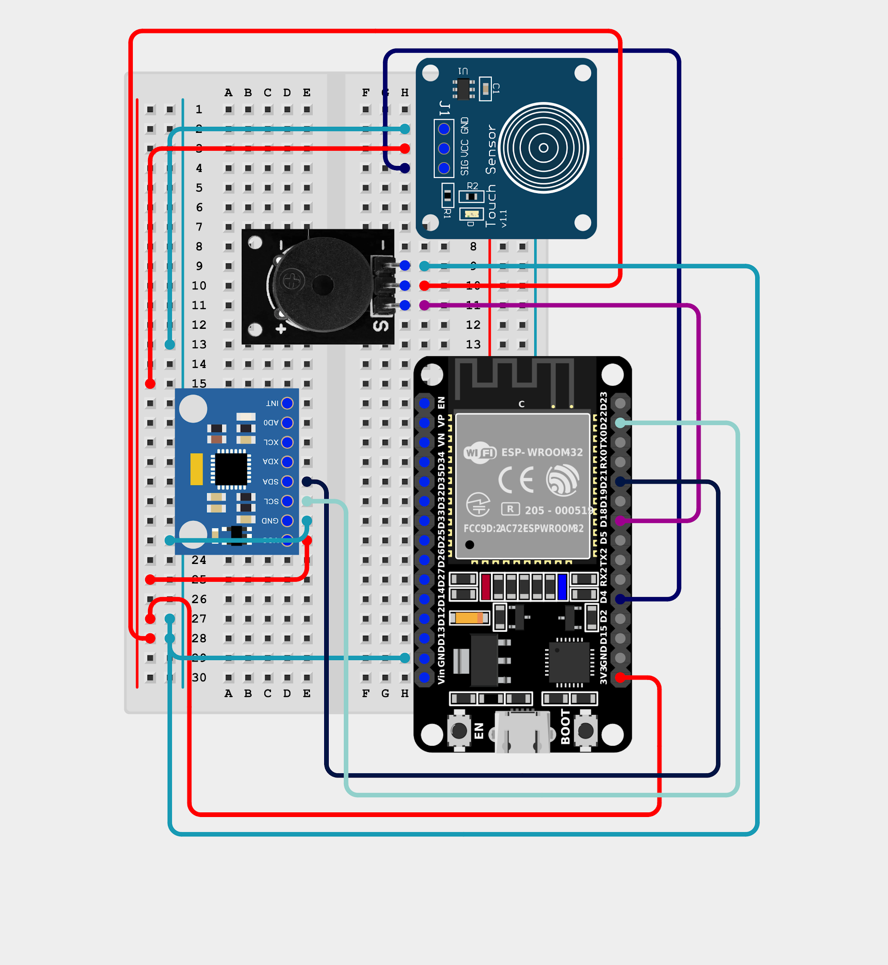
Touch + MPU6050 — MPU SDA/SCL share the I²C pins (GPIO 21/22). The OLED and buzzer are not used in this experiment.
Full Code — ESP32
/*
TouchForge — Tilt-to-Aim + Touch-to-Shoot Mouse Controller
------------------------------------------------------------------
Sends over USB serial:
TILT,<rollAngle>,<pitchAngle> (continuous, for mouse movement)
SHOOT_ON / SHOOT_OFF (touch sensor, edge-detected)

A Python script reads these and moves/clicks the real mouse, so
this works with any mouse-aimed browser game -- the game itself
is not modified in any way.

Wiring:
MPU6050 VCC -> 3.3V | GND -> GND | SDA -> GPIO 21 | SCL -> GPIO 22
Touch SIG -> GPIO 4 | VCC -> 3.3V | GND -> GND
*/

#include <Wire.h>
#include <MPU6050_light.h>

MPU6050 mpu(Wire);

const int TOUCH_PIN = 4;
int lastTouch = LOW;

void setup() {
Serial.begin(115200);
pinMode(TOUCH_PIN, INPUT_PULLDOWN);

Wire.begin(21, 22);
mpu.begin();

Serial.println("Calibrating... keep the sensor still!");
mpu.calcOffsets();
Serial.println("Ready.");

void loop() {
mpu.update();

float roll = mpu.getAngleX();
float pitch = mpu.getAngleY();

// Send raw angles every cycle -- Python converts these to mouse movement
Serial.print("TILT,");
Serial.print(roll);
Serial.print(",");
Serial.println(pitch);

// Touch = shoot, edge-detected like every other experiment
int t = digitalRead(TOUCH_PIN);
if (t == HIGH && lastTouch == LOW) Serial.println("SHOOT_ON");
if (t == LOW && lastTouch == HIGH) Serial.println("SHOOT_OFF");
lastTouch = t;

delay(30); // ~33 updates/sec -- smooth enough for aiming
}
Code Walkthrough
- mpu.update() must be called every loop to refresh the angles.
- Raw angles are sent as-is — all the mapping logic lives in Python, so you can tune the feel without re-flashing the board.
- delay(30) keeps the update rate smooth for aiming without flooding the serial port.

The Python Controller
Run it on your PC
- pip install pyserial pyautogui
Edit PORT = "COM3" to match the port shown in Arduino IDE (on Mac/Linux it looks like /dev/ttyUSB0).
}
- ​Close the Arduino Serial Monitor first — only one program can use the port.
- Run the Python script below, click into the game window once to focus it, then tilt to aim and touch to shoot.
Full Code — Python
"""
TouchForge — Serial-to-Mouse Game Controller (full-screen tilt mapping)
"""

import serial
import pyautogui
import time
import sys

PORT = "COM3"
BAUD = 115200

# The tilt angle (in degrees) that corresponds to the FAR EDGE of the screen.
# Tilt beyond this in either direction just stays pinned at the edge.
# Lower this number if you want the edges reachable with LESS tilt.
MAX_ROLL_ANGLE = 30 # left/right tilt range
MAX_PITCH_ANGLE = 25 # forward/back tilt range

pyautogui.FAILSAFE = True
pyautogui.PAUSE = 0

screen_w, screen_h = pyautogui.size()
MARGIN = 5

def clamp(value, lo, hi):
return max(lo, min(hi, value))

def map_range(value, in_min, in_max, out_min, out_max):
"""Maps value from [in_min, in_max] to [out_min, out_max], clamped at the ends."""
value = clamp(value, in_min, in_max)
return out_min + (value - in_min) * (out_max - out_min) / (in_max - in_min)

def main():
try:
ser = serial.Serial(PORT, BAUD, timeout=1)
except serial.SerialException as e:
print(f"Could not open {PORT}: {e}")
print("Check the COM port name and make sure Arduino Serial Monitor is closed.")
sys.exit(1)

print(f"Connected on {PORT}.")
print(f"Screen size: {screen_w}x{screen_h}")
print("Click into the game window ONCE manually to focus it, then tilt to aim.")
print("Press Ctrl+C here to stop.")

pyautogui.moveTo(screen_w // 2, screen_h // 2)
mouse_down = False

try:
while True:
line = ser.readline().decode(errors="ignore").strip()
if not line:
continue

if line.startswith("TILT,"):
parts = line.split(",")
if len(parts) == 3:
try:
roll = float(parts[1])
pitch = float(parts[2])
except ValueError:
continue

# roll: -MAX_ROLL_ANGLE -> left edge, +MAX_ROLL_ANGLE -> right edge
target_x = map_range(roll, -MAX_ROLL_ANGLE, MAX_ROLL_ANGLE,
MARGIN, screen_w - 1 - MARGIN)

# pitch: +MAX_PITCH_ANGLE (tilt forward) -> top edge, so it's inverted
target_y = map_range(pitch, -MAX_PITCH_ANGLE, MAX_PITCH_ANGLE,
screen_h - 1 - MARGIN, MARGIN)

pyautogui.moveTo(target_x, target_y, duration=0, _pause=False)

elif line == "SHOOT_ON" and not mouse_down:
pyautogui.mouseDown(_pause=False)
mouse_down = True

elif line == "SHOOT_OFF" and mouse_down:
pyautogui.mouseUp(_pause=False)
mouse_down = False

except KeyboardInterrupt:
print("\nStopping.")
except pyautogui.FailSafeException:
print("\nCursor hit a screen corner (failsafe).")
finally:
if mouse_down:
pyautogui.mouseUp(_pause=False)
ser.close()

if __name__ == "__main__":
main()
Code Walkthrough
- map\_range(): converts a tilt angle into a screen coordinate, clamped at the ends so over-tilting just pins the cursor to the edge.
- MAX\_ROLL\_ANGLE = 30 / MAX\_PITCH\_ANGLE = 25: the tilt that reaches the far edge of the screen. Lower these numbers to reach the edges with less tilt.
- Pitch is inverted — tilting forward moves the cursor up, like a joystick.
- MARGIN keeps the cursor a few pixels off the screen corners, because pyautogui.FAILSAFE aborts the script if the cursor touches a corner.
- The finally block always releases the mouse button, so an interrupted run never leaves a click stuck down.
Checkpoint
Keep the board flat while it calibrates. Run the script → tilt left/right and forward/back and the mouse cursor sweeps the whole screen. Touch the pad → the mouse button presses; release → it lets go. Open any mouse-aimed browser game and play with it.
Common Errors
- ​"Could not open COM3": wrong port name, or the Arduino Serial Monitor is still open.
- ​Cursor drifts when the board is flat: restart the board and keep it perfectly still during Calibrating....
- ​Cursor is too slow to reach the edges: lower MAX\_ROLL\_ANGLE / MAX\_PITCH\_ANGLE.
- ​Left/right feels backwards: mount the board the other way round, or negate the roll value in the script.
- ​Script stops suddenly: the cursor hit a screen corner (failsafe). Keep the MARGIN.
- ​Clicks do nothing in the game: click into the game window once to give it focus first.
What changed from Experiment 4
- The output is no longer the OLED or buzzer — it is your PC, over USB serial.
- New input: the MPU6050 on the same I²C pins the OLED used.
- The touch sensor is now sent as a continuous press / release pair (SHOOT\_ON / SHOOT\_OFF) instead of a single tap.
You've Built the Full TouchForge Toolkit
From a single touch lighting an LED, to a Dino game, a Morse key, a millisecond reaction timer, and finally a tilt-and-touch game controller for your PC — five working experiments, each one building directly on the last.
Experiments 1 – 5 Complete

